# The Littlest JupyterHub

**https://tljh.jupyter.org/en/latest/**

https://tljh.jupyter.org/en/latest/install/custom-server.html

1. 安装tljh:

<https://tljh.jupyter.org/en/latest/install/custom-server.html>

sudo apt install python3-pip

pip3 install conda

1. 设置基于IP的自签名证书：

<https://www.digitalocean.com/community/tutorials/how-to-create-a-self-signed-ssl-certificate-for-apache-in-ubuntu-16-04>

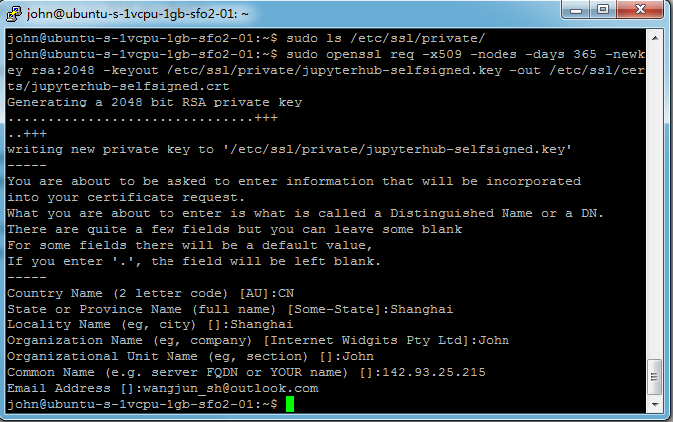

1. 手动设置SSL证书

<https://tljh.jupyter.org/en/latest/howto/admin/https.html>

sudo tljh-config set https.enabled true

sudo tljh-config set https.tls.key /etc/ssl/private/jupyterhub-selfsigned.key

sudo tljh-config set https.tls.cert /etc/ssl/certs/jupyterhub-selfsigned.crt

sudo tljh-config show

sudo tljh-config reload proxy

jupyterhub管理员：

john

Hellotheword

<https://142.93.25.215/user/john/tree>?

LDAP:

<https://github.com/jupyterhub/ldapauthenticator#required-configuration>

sudo pip3 install jupyterhub-ldapauthenticator

为Jupyterhub添加R内核：

安装R devtool (虚拟机的内存太小，编译通不过)

<https://www.digitalocean.com/community/tutorials/how-to-install-r-packages-using-devtools-on-ubuntu-18-04>

<https://github.com/IRkernel/IRkernel>

sudo apt install build-essential libcurl4-gnutls-dev libxml2-dev libssl-dev

sudo -i R

install.packages('devtools')

失败，内存太小，编译通不过：

*devtools::install_github(“IRkernel/IRkernel”)*

IRkernel::installspec(user = FALSE)

增加虚拟内存：

<https://www.digitalocean.com/community/tutorials/how-to-configure-virtual-memory-swap-file-on-a-vps>

<https://www.digitalocean.com/community/tutorials/how-to-add-swap-space-on-ubuntu-16-04>

<https://deanattali.com/2015/05/09/setup-rstudio-shiny-server-digital-ocean/>

之后安装成功了：

*devtools::install_github(“IRkernel/IRkernel”)*

IRkernel::installspec(user = FALSE)

sudo /opt/anaconda3/bin/conda install rpy2

~~NOT WORKING:~~

*~~conda update ipython-notebook~~*

~~sudo /opt/anaconda3/bin/conda install -c r r-essentials~~

~~sudo /opt/anaconda3/bin/conda install -c r r-irkernel~~

R notebook in Jupyterhub:

<https://www.datacamp.com/community/blog/jupyter-notebook-r>

<https://blog.revolutionanalytics.com/2016/01/pipelining-r-python.html>

<https://www.linkedin.com/pulse/interfacing-r-from-python-3-jupyter-notebook-jared-stufft/>

**Jupyterhub**

[**https://github.com/jupyterhub/jupyterhub**](https://github.com/jupyterhub/jupyterhub)

**docker:**

[**https://hub.docker.com/r/jupyter/datascience-notebook/**](https://hub.docker.com/r/jupyter/datascience-notebook/)

[**http://www.exegetic.biz/blog/2017/07/jupyter-docker-aws/**](http://www.exegetic.biz/blog/2017/07/jupyter-docker-aws/)

[**https://opendreamkit.org/2018/10/17/jupyterhub-docker/**](https://opendreamkit.org/2018/10/17/jupyterhub-docker/)

[**https://towardsdatascience.com/jupyter-data-science-stack-docker-in-under-15-minutes-19d8f822bd45**](https://towardsdatascience.com/jupyter-data-science-stack-docker-in-under-15-minutes-19d8f822bd45)

How to Use Restful Web APIs in Python

<https://code.tutsplus.com/articles/how-to-use-restful-web-apis-in-python--cms-29493>

# Python API tutorial - An Introduction to using APIs

<https://www.dataquest.io/blog/python-api-tutorial/>

# Python API tutorial - An Introduction to using APIs

<https://www.dataquest.io/blog/python-api-tutorial/>

# How To Use Web APIs in Python 3

<https://www.digitalocean.com/community/tutorials/how-to-use-web-apis-in-python-3>

# GET and POST requests using Python

<https://www.geeksforgeeks.org/get-post-requests-using-python/>

# Making HTTP Requests in Python - Tutorial

<https://tutorialedge.net/python/python-http-requests-tutorial/>

### How to Use RESTful APIs with Django

<https://simpleisbetterthancomplex.com/tutorial/2018/02/03/how-to-use-restful-apis-with-django.html>

## SSL Cert Verification

<http://docs.python-requests.org/en/master/user/advanced/#ssl-cert-verification>

<https://gist.github.com/larrycai/7823499>

PANDAS DATAFRAME from JSON

**Parsing Nested JSON with Pandas**

<https://www.kaggle.com/jboysen/quick-tutorial-flatten-nested-json-in-pandas>

<https://pandas.pydata.org/pandas-docs/stable/api.html#json>

XML to dataframe

<http://www.austintaylor.io/lxml/python/pandas/xml/dataframe/2016/07/08/convert-xml-to-pandas-dataframe/>

<https://blog.csdn.net/u014281392/article/details/79961297>

<http://gokhanatil.com/2017/11/python-for-data-science-importing-xml-to-pandas-dataframe.html>

<https://gist.github.com/mattmc3/712f280ec81044ec7bd12a6dda560787>

<https://www.datacamp.com/community/tutorials/python-xml-elementtree>

<https://www.datasciencebytes.com/bytes/2015/03/19/analyzing-large-xml-files-in-python/>

# [XML to Pandas Data frame](http://www.stuartmathews.com/index.php/programming/928-xml-to-pandas-data-frame)

<http://www.stuartmathews.com/index.php/programming/928-xml-to-pandas-data-frame>

<https://hopstat.wordpress.com/2014/01/14/faster-xml-conversion-to-data-frames/>

## ggplot2 in Python

Plotnine

conda install -c conda-forge plotnine

<https://plotnine.readthedocs.io/en/stable/>

<https://www.kaggle.com/residentmario/grammar-of-graphics-with-plotnine-optional>

<http://pltn.ca/plotnine-superior-python-ggplot/>

<https://nipunbatra.github.io/blog/2017/50-ggplot-python-1.html>

<https://zhuanlan.zhihu.com/p/30933555>